IndiYatra — To Do
Task tracker for upcoming IndiYatra feature work.
- Mobile snippet player: tap-to-reveal card with swipe navigation
On mobile, redesign the snippet card so only the hook and image show by default (story-style cover). The hook is at the top and the image is below the hook. (the mock up shows the other way round). Tapping the card reveals a bottom sheet with the rest of the content - explanation, key term, life connection, refresher question, and citations. The sheet header (hook) stays pinned/sticky while its body scrolls independently for long content, using the same overflow-y: auto pattern already used for the comments sheet in SnippetPlayer.jsx. Swiping left or right still navigates to the next or previous snippet using the existing touch handlers, and re-collapses the sheet on navigation. Desktop keeps the current two-column layout.
The top navigation bar will continue in the current design. The bottom bar of the snippet which has like, comment, bookmark and share will also continue the same way. The edit button will also continue. The mockup does not properly represent these features. It only illustrates the tap to reveal other content.
Reference: interactive mockup approved in chat. Screenshots below.
Before tap — hook + image cover
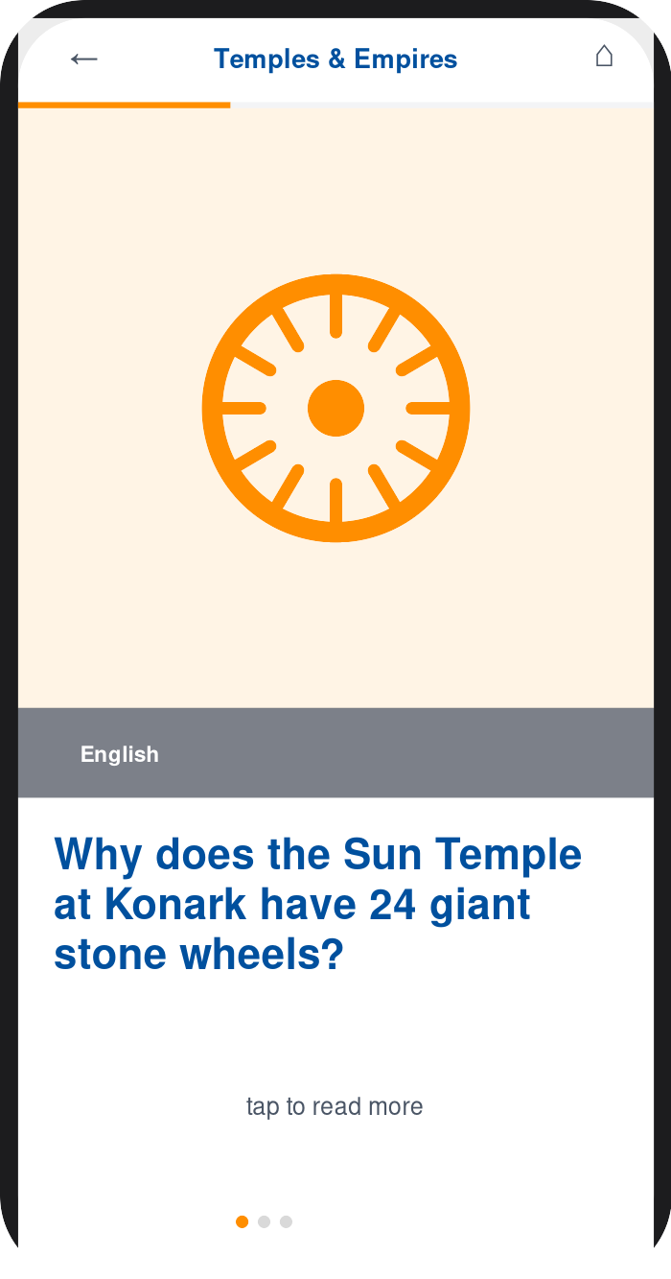
After tap — explanation sheet revealed
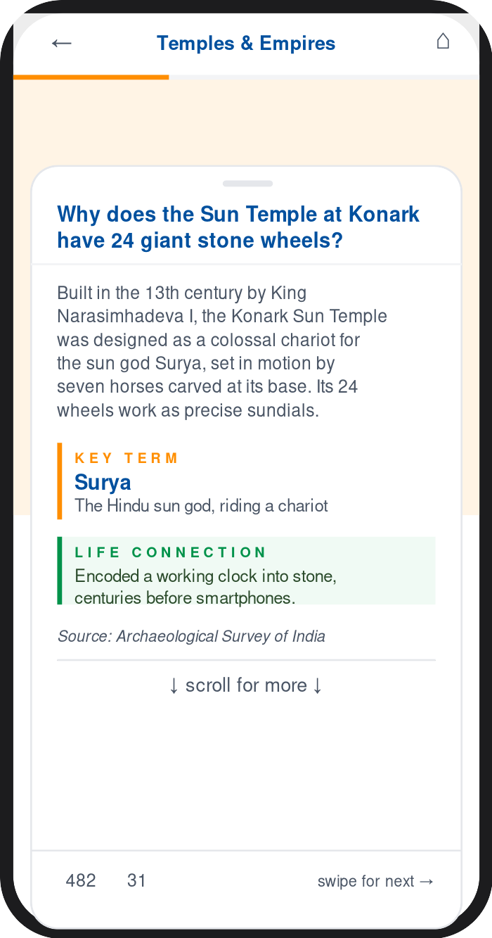
- Top and Bottom Nav Bars
Bottom Nav Bar. The bottom nav bar (standard across all screens except snippet player) will have Home, a new tab called “All Courses”, For You, Dashboard and Discover.
Top Nav Bar. The top Nav bar will have the IndiYatra logo on the left. It will have a set of three buttons on the right for Language Selection, Font Size Selection and Profile Settings. In the middle it will have the Resume button and depending on the user profile, the Admin and Edit Buttons

- All Courses: quick-commerce style category drawer for browsing the full content tree
The All Courses tab in the bottom nav bar functions like Zepto/Blinkit’s category drawer. Tapping it opens a two-pane screen: a left sidebar listing Courses, which expands inline to Levels, which expands inline to Themes (accordion behavior, one branch open at a time). All texts wrap when needed in the sidebar. Selecting a theme populates the main pane, split top and bottom. The top half shows that theme’s Modules as circular speedometer-gauge buttons — the gauge’s arc fill and color reflect % of lessons completed (gray under 25%, saffron 25–50%, heritage blue 51–75%, green above 75%), with the module name and “X lessons · Y stories” underneath. Tapping a module loads its Lessons as pill cards in the bottom half, each showing the lesson title plus two mini action buttons: Read (saffron, matching the Explore/Resume CTA color on the courses page) and Quiz (heritage blue, matching the existing quiz-recap color). Quiz button is disabled when no quiz is available.The modules pane and lessons pane scroll independently and vertically (each needs its own overflow-y: auto and min-height: 0 on all ancestor flex containers, plus overscroll-behavior: contain so a drag in one pane doesn’t bleed into the other or the sidebar).
Reference: interactive mockup approved in chat. Screenshot below. It shows the All Stories tab but it should read as All Courses. The top nav bar is not represented properly in the mockup. Use the standard top nav bar. The text All Courses + Course + Level + Theme should appear below the Top Nav bar in two lines in the same format as in the mockup. Use the teal colour from the brandbook for sidebar and lesson pill cards.
All Courses — course/level/theme drawer with module gauges and lesson actions
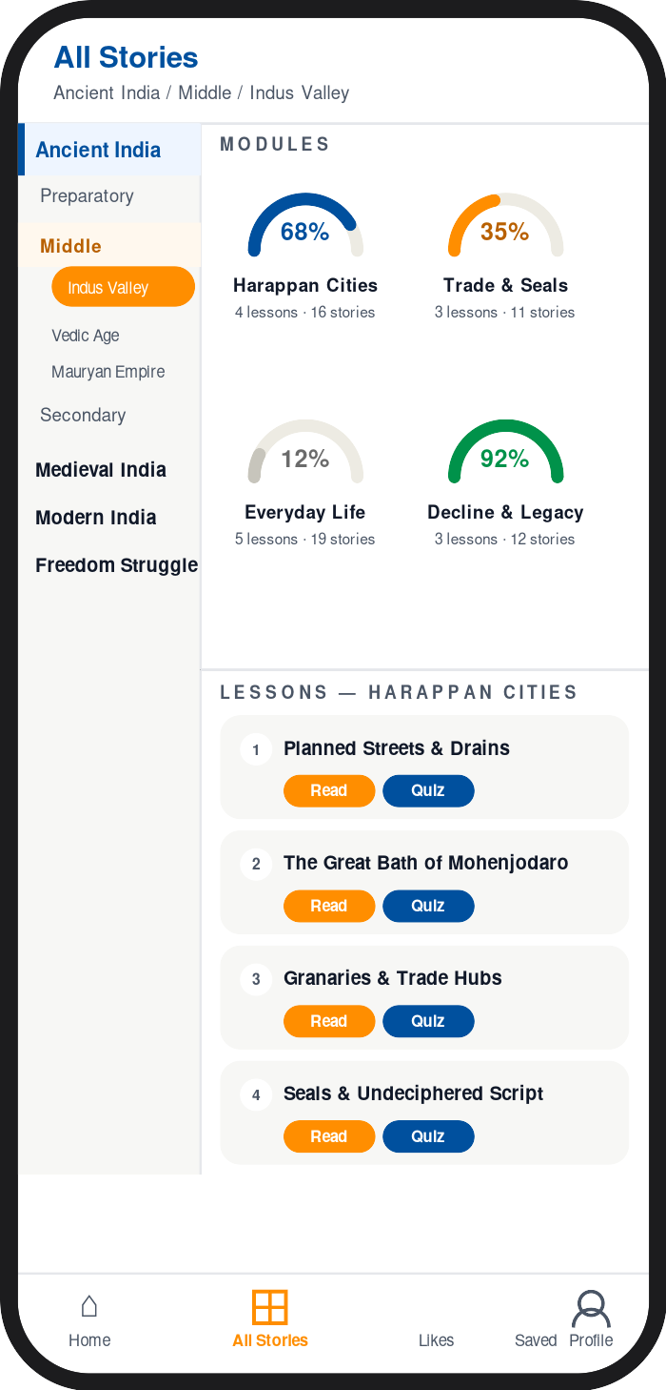

For You Screen — Sidebar Redesign + All Courses Integration
Redesign the mobile For You screen with two changes: (1) replace the current vertical scroll layout with a compact sidebar navigation, and (2) add an All Courses entry that replicates the All Courses drawer behaviour.

Change 1: Sidebar navigation
Replace the full-page scroll layout with a two-pane design. A narrow left sidebar (≈88 px) holds round icon-and-label buttons for every existing block. The main panel to the right shows only the content for the selected button. One button is active (highlighted) at a time.
Sidebar buttons (top to bottom):
- Resume — shows the Resume Yatra progress card in the main panel
- All Courses – add an All Courses button just below Resume (detailed after this bullet list)
- Based on Your Interest — shows the personalised recommendations rail
- Most Liked — shows the most-liked lessons carousel
- Most Bookmarked — shows the most-saved lessons carousel
- My Likes — shows the user’s liked snippets and Play All button
- My Bookmarks — shows the user’s bookmarked lessons and snippets

Change 2: All Courses button
Add an All Courses button below the Resume button in the sidebar. Tapping it highlights the button in heritage blue and expands a course tree inline beneath it. It behaves the same way as clicking the All Stories button in the bottom nav menu. (Course → Levels accordion → Themes). Selecting a theme populates the main panel with:
- Module progress — speedometer-arc gauge buttons for each module. Arc colour encodes progress: grey (0%), saffron (1–49%), heritage blue (50–74%), green (75%+). Tapping a gauge loads that module’s lessons below.
- Lesson list — each lesson row shows its completion state plus two action buttons: Read (saffron, opens the snippet player) and Quiz (heritage blue, opens the quiz). Quiz button is disabled when no quiz is available.
Reference: interactive mockup saved as ForYou_Redesign_Mockup.html. Screen captures below. The mockup does not represent the top nav menu and the bottom nav menu; and these continue as before
Screen 1 — For You sidebar, Resume selected

Screen 2 — All Courses selected, Ancient India theme expanded
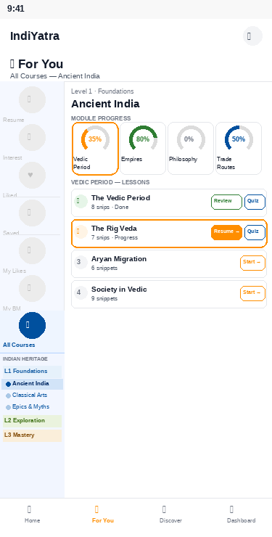

Discover Page — Tag Cloud Redesign (Option A: Uniform Chips + Count Badges)
Replace the multi-size tag word cloud on the Discover page with uniform chips. One font size everywhere; popularity is shown by a small count badge inside each chip instead of font size.
- Tags: white pill chips (1px border) with the tag name plus a small grey count badge. Top tags (count ≥ 20) get a subtle saffron tint on background and border.
- Categories: keep the existing pill style, add the same count badges.
- Active state: Heritage Blue fill with white text; the count badge becomes translucent white.
- Typography: one size for all chips — 0.875rem Nunito Sans 600. No more multi-size, multi-colour cloud.
- Reference: mockup approved in chat — Discover_Redesign_Options.html, Option A.

Unified Block Style for Module / Lesson / Snippet Cards
Right now every place a Module, Lesson, or Snippet is shown as a block uses a slightly different visual style — different corner radius, border colour, and shadow — even though the intent is the same each time. On the For You page alone, Based on Your Interest, Most Liked, Most Bookmarked, My Likes, and My Bookmarks each render their cards differently. Replace these with one shared block style, reused everywhere a Module, Lesson, or Snippet appears (For You, Dashboard, Likes page, Bookmarks page, the Based-on-Interest rail, and the course cards on the Home page), not just on this one page.
- Module container: keep the teal-tinted block already shared between the All Courses page and the For You course panel — background #EAF6F5, 1px #C2E4E2 border, 16px corner radius. This becomes the standard wrapper anywhere lessons are grouped under a module.
- Grid / carousel card: for any lesson or snippet shown with a thumbnail (Based on Your Interest, Most Liked, Most Bookmarked, My Likes, the Home page course cards) — white background, 1px border in rgba(0,0,0,0.08), 14px corner radius, no drop shadow, border turns saffron on hover. Same recipe as the existing All Courses lesson card, just with a thumbnail slot added on top.
- Row card: for compact list contexts (My Bookmarks, Dashboard recent activity) — icon on the left, title and subtitle in the middle, chevron on the right, using the same border colour, radius, and hover treatment as the grid card so it reads as the same family, just a different layout.
- Drop: the box-shadows currently on the Likes page and Bookmarks page cards, so every block relies on the same flat border treatment instead of some having shadows and others not.
- Reference: before/after mockup shown in chat comparing the current versus proposed styles for Based on Your Interest, My Likes, and My Bookmarks.

Likes and Bookmarks for Modules, Lessons, Quizzes, and Questions
Snippets and quiz questions already support like and bookmark, both fully reversible — tap again to undo. Extend the same pair of actions to the Module and Lesson blocks, and add per-question like/bookmark inside the quiz player. In both the Module row and the Lesson row, the like (heart) button now sits stacked directly above the bookmark (ribbon) button, and that pair sits above the block’s action button(s) — Explore/Resume for modules, Learn + Quiz for lessons — rather than inline alongside them. Lesson rows also gain a small colour image thumbnail (their own asset_id, independent of the parent module’s image) so the list reads less text-heavy.

Propagation rules
- Module: stands alone. Liking or bookmarking a module never affects anything below it.
- Lesson ↔ Quiz: bidirectional pair. Liking or bookmarking either one marks both; nothing below — the lesson’s individual snippets, or the quiz’s individual questions — is touched.
- Question ↔ Snippet: bidirectional pair, but only for snippet-linked quiz questions (one question tied one-to-one to one snippet via snippet_questions). Standalone questions have no snippet to pair with, and simply stay as their own liked/bookmarked question.
- Unlike mirrors like: removing a like or bookmark from either side of a pair removes it from both, symmetrically.
- New content_type: the likes and bookmarks tables gain a fifth type, quiz, alongside module, lesson, snippet, and question, so every entity can be told apart.
- My Likes / My Bookmarks: both pages, plus the Most Liked/Most Bookmarked leaderboards, now filter by Module, Lesson, Quiz, Stories, and Questions. The Most Liked/Most Saved Lessons ranking on For You switched from summing child-snippet likes to each lesson’s own direct like/bookmark count.
Reference: mockup approved in chat. Screenshots below.
Module block — like and bookmark stacked above the Resume/Explore button
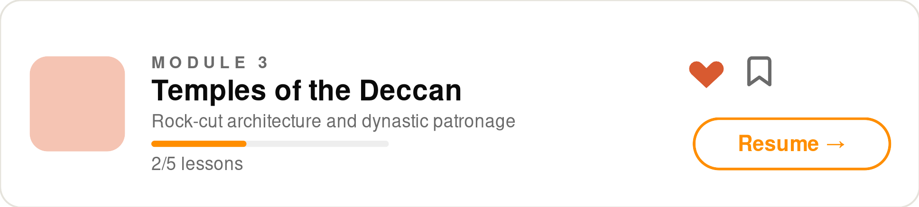
Lesson block — like and bookmark stacked above Learn/Quiz, with its own image thumbnail
